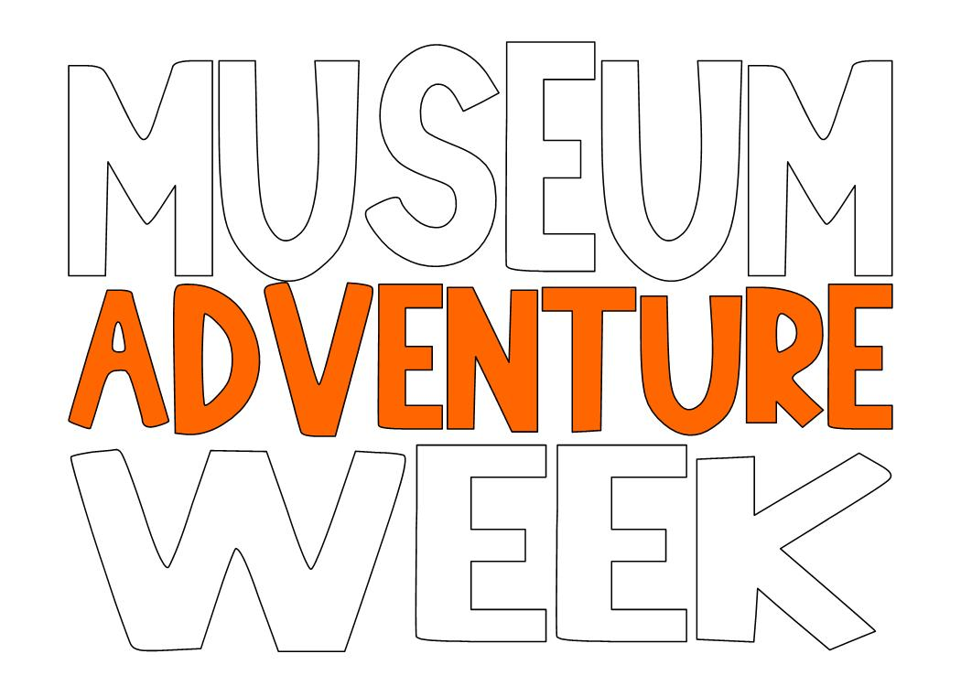
Junior Chef: Tastes of NEPA Scholarships Available!
During the week of July 8th – July 12th, Everhart Museum campers will become culinary experts while learning about local food traditions of NEPA. By the end of the week, students will develop team recipes, cultivate locally sourced foods, and prepare their dishes for a final presentation.
The Everhart Museum is offering Six (6) scholarships sponsored by Wegmans to campers entering grades first through sixth who are interested in the culinary arts. Recipients will be selected based on an Essay Competition!
Essay Requirements as follows:
- In 250 words or less, please write an essay that answers the following questions on the attachment provided:
What food traditions do you have in your family?
- “Tradition: the transmission of customs or beliefs from generation to generation.”

- Please complete the attached form in full in order to be entered into contest.
  - Digital submissions can be sent to:
education@everhart-museum.org

  - Physical submissions can be mailed to:
Junior Chef Essay Contest
C/O Everhart Museum
1901 Mulberry St.
Scranton, PA 18510
Essays must be submitted no later than Monday, June 17th
Scholarship recipients will be contacted via phone no later than Friday, June 21st
Campers already registered for Junior Chef: Tastes of NEPA may enter as well!
Good luck!!!

