Everhart Logo copy.jpg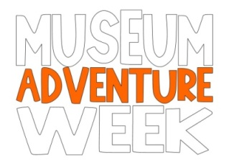

**USING 250 WORDS OR LESS, ANSWER THE FOLLOWING QUESTION AS CREATIVELY AS YOU CAN!**

**What food traditions do you have in your family?**

Tradition: the transmission of customs or beliefs from generation to generation.

**JUNIOR CHEF   
ESSAY CONTEST FORM**

**Name:  
  
________________________**

**Age:**

**_____________**

**Grade:**

**_____________**

**School:**

**__________________________**

**Parent/Guardian:**

**_________________________**

**Email (parent/guardian):**

**_________________________**

**Phone (parent/guardian):**

**_________________________**

**Please complete the form below in full to ensure that your essay is entered into the contest.**