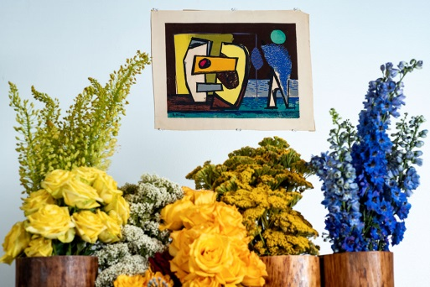
February 2019
To Whom It May Concern:
This spring, the Everhart Museum will launch its first annual Art in Bloom. Art in Bloom events are held at museums across the country, drawing thousands of visitors to view floral interpretations of museum collections. This two-day event will feature a ticketed evening reception on Friday, April 26 at 6:00 pm, showcasing fresh art-inspired floral arrangements created by local designers. On Saturday, April 27 from 1:00 pm-4:00 pm, a free public community day will offer guests the opportunity to participate in guided workshops, lectures, tours of the galleries and shop for nature-inspired creations by local fine artists and traditional crafters.
We are currently seeking partners that would be interested in joining in celebrating nature at our first annual Art in Bloom Community Day! This event attracts over 1,000 patrons of the arts and humanities of all ages and provides our participating partners a venue to showcase the amazing things our area has to offer.
Community partners have the option of participating in one of three ways:
Option 1: Presenting Partner: How do you interpret Art in Bloom?
This option is for any partner who is interested in presenting an activity, demonstration or talk on the specific theme designated to community day. Presenting partners will be required to describe their presentation in order to be approved by Museum staff. Option one is selected on a first come, first serve basis, as space is limited.
Option 2: Partner Table
This option is for partners who would like to set up a manned information table. Since only eight spots are available, option two is offered on a first come, first served basis. The Museum will provide one 6-foot table. Partner must provide linens, all display items and table must be staffed for the full length of the event.
Option 3: Merchandise Vendor
Do you have something great to share inspired by our theme? We are offering a limited number of vendor tables, free of charge, to those who submit a letter of interest and a sample of their product. Deadline for vendor submissions is: March 29. 2019. The Everhart is looking for a variety of products, so all submissions will be juried and selected and notified by April 1st.
A return form is included. If interested in participating, please complete the form in full and return to:
Everhart Museum of Natural History, Science and Art
c/o Programs Department
1901 Mulberry Street
Scranton, PA 18510
Or via email at programs@everhart-museum.org. To participate as a designer please call 570-346-7186 ext. 516.
We look forward to hearing from you!
Stefanie Colarusso, Director of Programs and Events Sarah Sutton, Manager of Educational Programs

COMMUNITY DAY PARTNERSHIP FORM
COMMUNITY DAY AT THE EVERHART
CALL FOR COMMUNITY PARTNERS
Deadline: March 29, 2019
We would like to participate as:

Option 1: Presenting Partner Option 2: Partner Table
Please complete the partnership form and return no later than Friday, March 2^{9,} 2019. We notify you immediately if we have any questions regarding your spatial needs or if spaces are still available.
NAME OF BUSINESS OR ORGANIZATION: _____________________________________________________________________
ADDRESS: __________________________________________________________________________________________________
CONTACT NAME: __________________________________ CONTACT EMAIL: _______________________________________
CONTACT PHONE NUMBER: ___________________________ ALT PH NUMBER FOR DAY OF: _________________________
PERSON(S) ATTENDING EVENT: ______________________________________________________________________________
All participating partners can arrive on April 27, 2019 between 10:00 AM and 12:00 PM. All partners must be set-up no later than 12:30 PM. Museum staff will be available to help with load-in at the back entrance of the Museum. All partners must check-in at the back entrance upon arrival.
Option 1: Please describe your planned activity/presentation and how it connects to the theme:
____________________________________________________________________________________________________________
____________________________________________________________________________________________________________
____________________________________________________________________________________________________________
Will you be bringing tech? If so, will you need the internet? _______________________________
What type of equipment will you be bringing? _______________________________
Please specify the approx. time you will arrive: ________________________________
If you have any questions, please contact us at your convenience at 570-346-7186 ext. 516

MERCHANDISE VENDOR FORM
COMMUNITY DAY AT THE EVERHART
CALL FOR COMMUNITY PARTNERS
Deadline: March 29, 2019
I am interested in participating as a merchandise vendor.

NAME OF BUSINESS OR ORGANIZATION: _____________________________________________________________________
ADDRESS: __________________________________________________________________________________________________
CONTACT NAME: __________________________________ CONTACT EMAIL: _______________________________________
CONTACT PHONE NUMBER: ___________________________ WEBSITE: _____________________________________________

Please attach this form and send with up to 4 JPEG images of your product via email to programs@everhart-museum.org with the subject line: ART IN BLOOM VENDOR APPLICATION.

Please describe your product and how it connects to the Art in Bloom theme:
____________________________________________________________________________________________________________
____________________________________________________________________________________________________________
____________________________________________________________________________________________________________

All vendors must be present on the day of the event. All submissions will be juried and final 8 selected will receive a free vendor space at the Community Day event on April 27, 2019. Each vendor will have one 6-foot table provided to them at no cost.

If you have any questions, please contact us at your convenience at 570-346-7186 ext. 516

